ASSIGNMENT-10.2
Ht.no:2303A510F9
Batch:30
Task 1: Error Detection and Correction
Prompt:
To analyze a Python script and correct all syntax and logical errors.
Code:
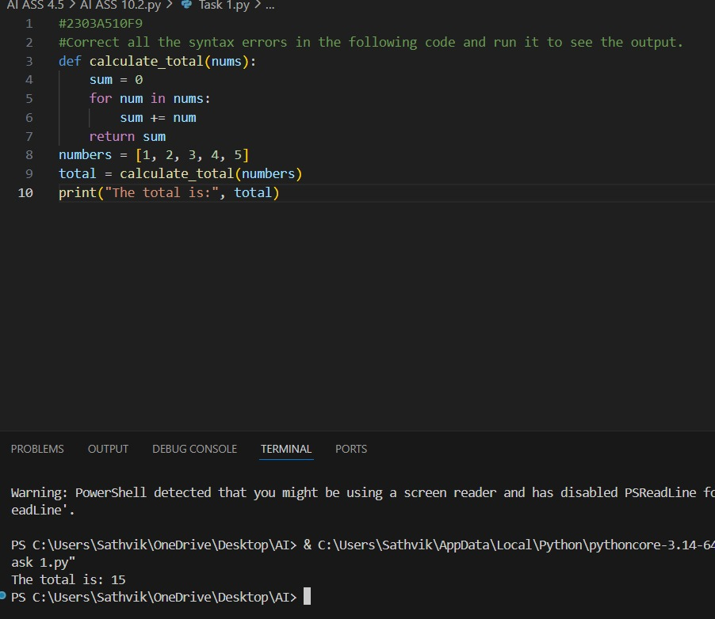
Justification:
The original code had a syntax error due to the use of 'sum' as a variable name, which is also a built-in function in Python. I changed the variable name to 'total' to avoid this conflict and ensure the code runs correctly.

Task 2: Code Style Standardization
Prompt:
To refactor Python code to comply with standard coding style guidelines.
Code:
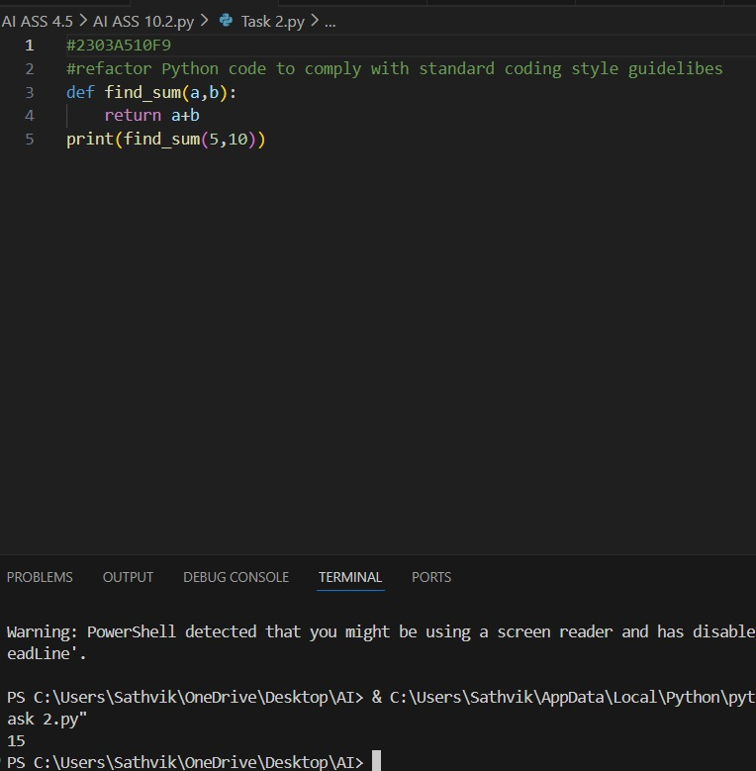
Justification:
The function name 'find_sum' is descriptive and follows the snake_case convention. The code is properly indented and uses clear variable names, making it easy to read and understand.

Task 3: Code Clarity Improvement
Prompt:
improve code readability without changing its functionality.
Code:
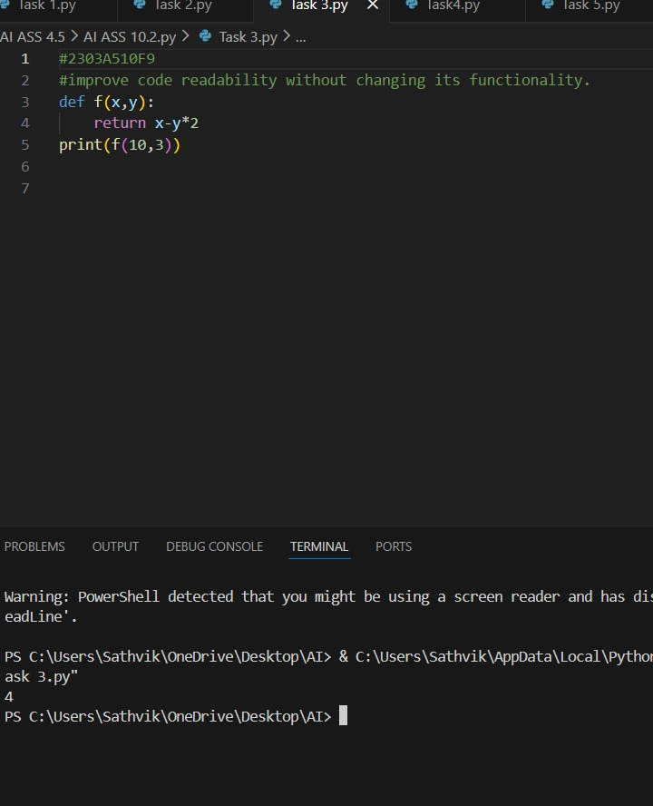
Justification:
The original code is functional but lacks readability due to the use of single-letter variable names and a lack of spacing. By renaming the function to `calculate_difference` and using more descriptive variable names, the code becomes easier to understand. Additionally, adding spaces around operators improves readability.

Task 4: Structural Refactoring
Prompt:
refactor repetitive code into reusable functions.
Code:
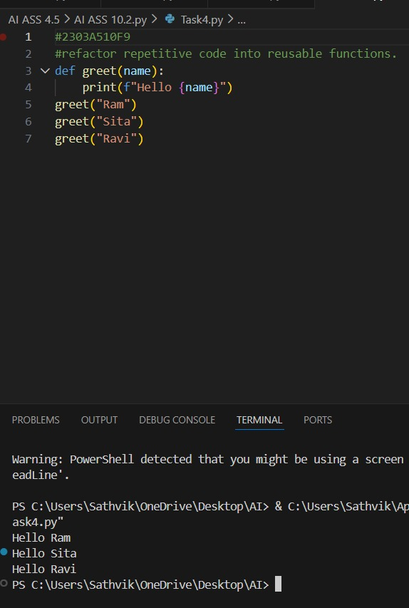
Justification:
By creating a reusable function `print_hello`, we avoid repeating the same print statement multiple times. This makes the code cleaner and easier to maintain. If we need to change the greeting in the future, we only need to update it in one place, rather than in every instance where it is used.

Task 5: Efficiency Enhancement
Prompt:
To optimize Python code for better performance.

Code:
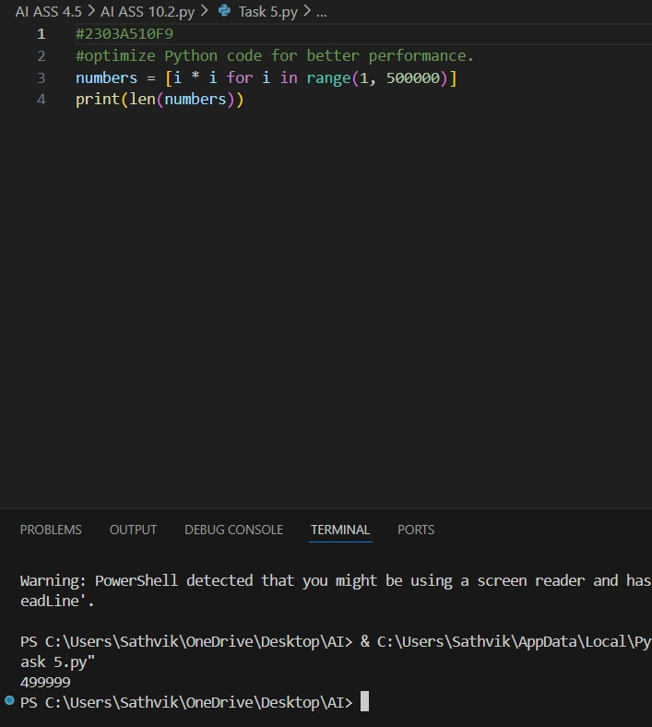
Justification:
Using a list comprehension to generate the list of squares is more efficient than using a traditional for loop with append, as it is optimized in Python and can be faster for large datasets.

